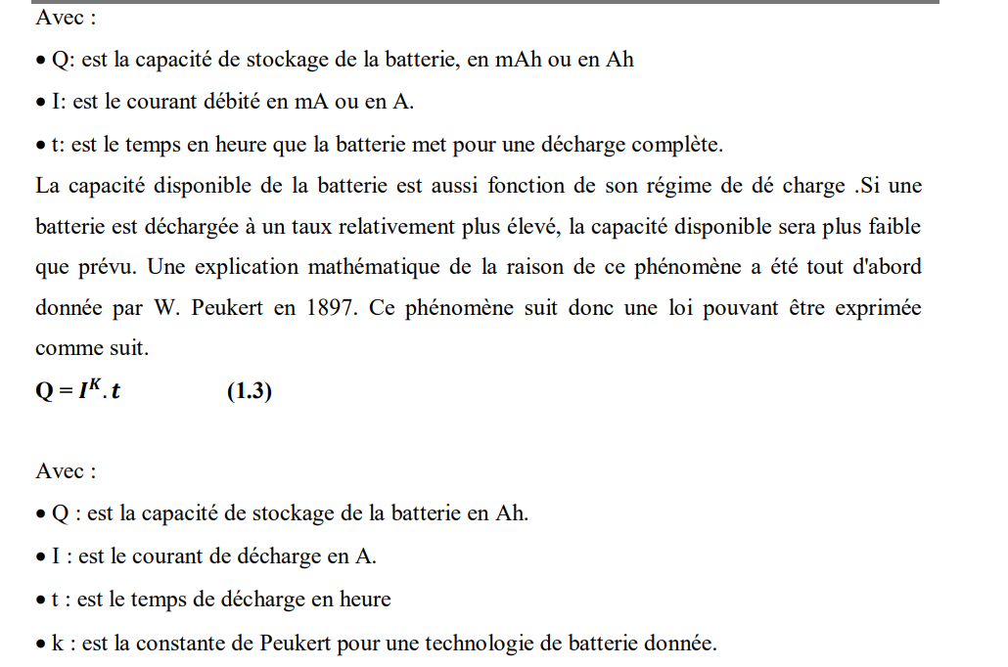

choix d’electrodes
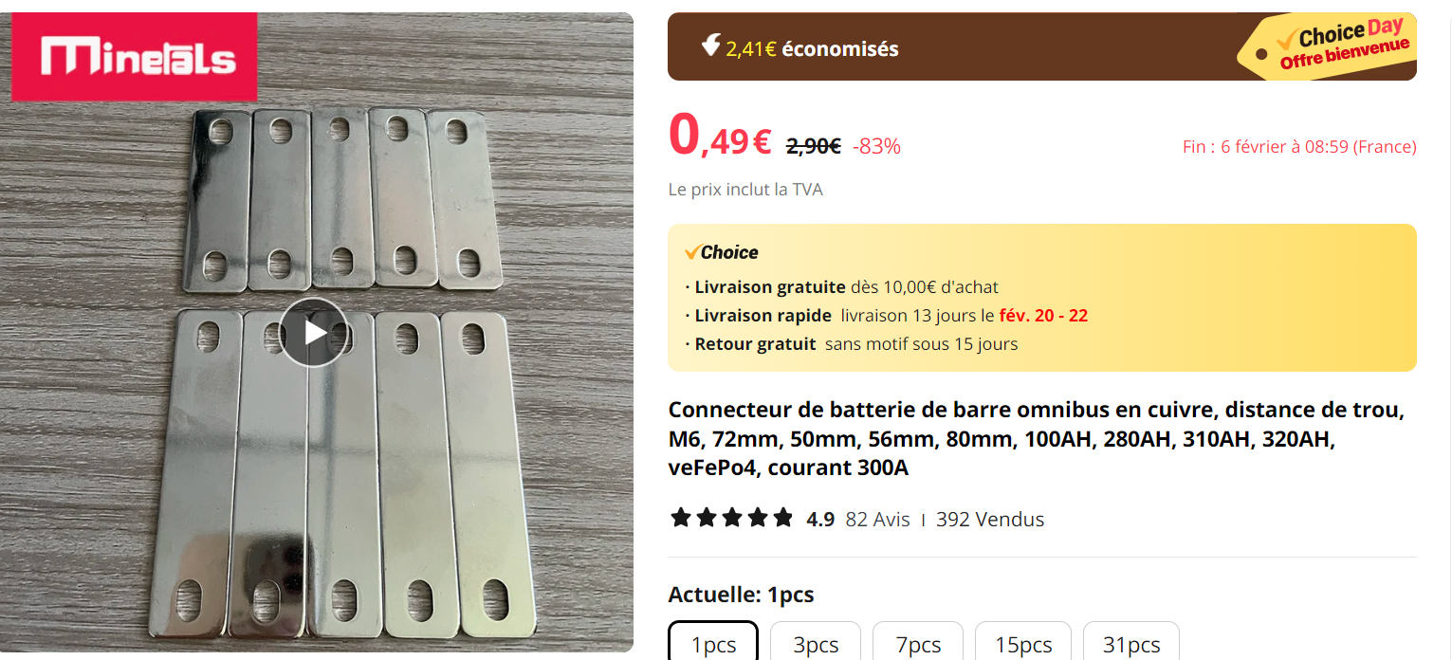

https://fr.aliexpress.com/item/1005005652738294.html?spm=a2g0o.detail.pcDetailTopMoreOtherSeller.3.2743bae17f6ii0&gps-id=pcDetailTopMoreOtherSeller&scm=1007.40000.327270.0&scm_id=1007.40000.327270.0&scm-url=1007.40000.327270.0&pvid=93ebbf17-09de-4c7a-8013-ba4026c8d7f2&_t=gps-id:pcDetailTopMoreOtherSeller,scm-url:1007.40000.327270.0,pvid:93ebbf17-09de-4c7a-8013-ba4026c8d7f2,tpp_buckets:668%232846%238111%231996&pdp_npi=4%40dis%21EUR%212.90%210.49%21%21%2122.12%213.73%21%40211b617a17069785410205563ed12e%2112000033895913581%21rec%21FR%21%21AB&utparam-url=scene%3ApcDetailTopMoreOtherSeller%7Cquery_from%3A&search_p4p_id=202402030842210684180786807887908647_2

isolant
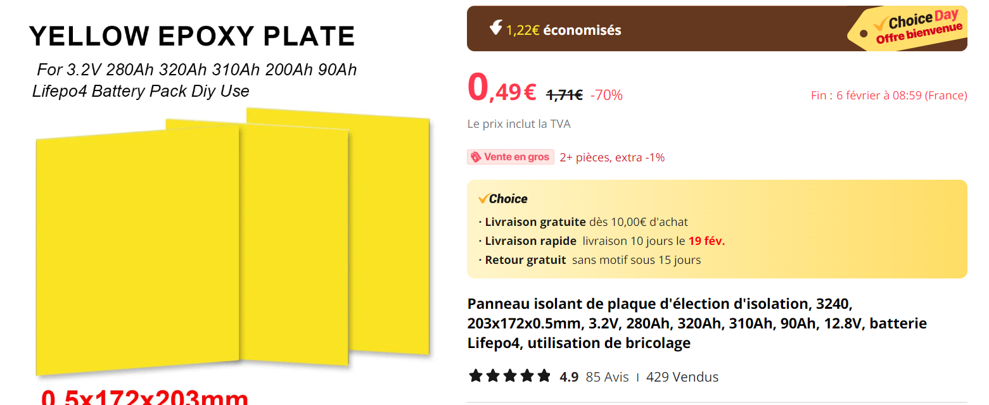

https://fr.aliexpress.com/item/1005005850378507.html?spm=a2g0o.detail.pcDetailBottomMoreOtherSeller.101.2743bae17f6ii0&gps-id=pcDetailBottomMoreOtherSeller&scm=1007.40000.326746.0&scm_id=1007.40000.326746.0&scm-url=1007.40000.326746.0&pvid=3229bbeb-f918-4b03-a76d-1be9c16ab99a&_t=gps-id:pcDetailBottomMoreOtherSeller,scm-url:1007.40000.326746.0,pvid:3229bbeb-f918-4b03-a76d-1be9c16ab99a,tpp_buckets:668%232846%238111%23472&pdp_npi=4%40dis%21EUR%211.71%210.49%21%21%211.82%210.53%21%402103854017069791498925819e0110%2112000034570935919%21rec%21FR%21%21AB&utparam-url=scene%3ApcDetailBottomMoreOtherSeller%7Cquery_from%3A

https://floordirekt.fr/products/gummiplatten-aus-sbr-gummi?variant=40331448058013&gad_source=1&gclid=CjwKCAiA0PuuBhBsEiwAS7fsNddM_yIFKmDAm1Lk_EFkgMlZoaHQ7VIlDxCOgQv9UDhAcD0_q3sHbRoCDpcQAvD_BwE

OK https://www.amazon.fr/ACIT-n%C3%A9opr%C3%A8ne-caoutchouc-polyur%C3%A9thane-%C3%A9paisseur/dp/B0BBRPN3B2/ref=asc_df_B0BBRPN3B2/?tag=googshopfr-21&linkCode=df0&hvadid=603056717431&hvpos=&hvnetw=g&hvrand=1415411321010810261&hvpone=&hvptwo=&hvqmt=&hvdev=c&hvdvcmdl=&hvlocint=&hvlocphy=9055236&hvtargid=pla-1880090718886&mcid=42fe2cc8df8e3ca48a93fd96677c72d1&th=1

OK
https://www.amazon.fr/Lot-anodes-cuivre-pur-galvanoplastie/dp/B07PYNRYX3/ref=sr_1_3?dib=eyJ2IjoiMSJ9.12DqFdZYm0eUmVtaULgV1PPKCGp4n08hRI0DWGS7ViPQOUvek1HCS6w4S7MgRVxPb3cAOMpMZiTTcIierl-WMcoVXorOqXuCtRNaEVzTIe8XHKIIr-RhSpGcgNGCHnL439o8wp49Mb4LV1yiMPqzqcJNV9wHjVFL-sVJGoK2TT4Yk8dCkfjKmdGrYoUhacpf-6fqajl-ObpKkkJLEwiMJCSC8AhJvTDAMnh1BEASKFR1TnmpPqo6HO2ZelL8UBq3gGyEDsC4513kiFTSoNbSUy_IZRTjcL-w9nM5VPr4Rks.8eAEOZHlyG_QrmvhadVZJVz1P6h5YCCdOiVdnj-zShk&dib_tag=se&keywords=plaque+de+cuivre&qid=1709553969&sr=8-3-spons&sp_csd=d2lkZ2V0TmFtZT1zcF9hdGY&psc=1

